**Web Design – Project 1**

**Report**

**IS-1**



**Created by:**

Syaiful Ardi Wijaya (Group Leader)

Diego Armando Parulian Siboro

Hilya Lubbi Imdad Alawy

Neyra Keysya Yusi Syafira

Steve Immanuel Andaria

*Faculty of Computer Science*

*President University*

**Purpose**

For our group project, we created a simple travel website that helps people find beautiful destinations in World. The purpose is to make trip planning easier and inspire others to explore the country’s amazing nature and culture. We built the site using basic web technologies like HTML, CSS, and Bootstrap, focusing on clean design and easy navigation.

# 1. Structure Folder/File

Project Web Design Folder

**├──**Login folder

**│ ├──**backg.jpg

**│ ├──**login.css

**│ ├──** login.html

**├──** Main folder

**├──**Css folder

**│ ├──**Main.css

**├──**Destination folder

**│ ├──**Amerika

**│ ├──**Canada

**│ ├──**Indonesia

**│ ├──**Italy

**│ ├──**Japan

**│ ├──**New Zealand

**│ *every destinations has it own html, css, and images**

**├──**Img folder

**│ ├──**Amerika flag

**│ ├──**Canada flag

**│ ├──**Indonesia flag

**│ ├──**Italy flag

**│ ├──**Japan flag

**│ ├──**New Zealand flag

**├──**Index.html

**├──**Main.html

**├──**Nav.html

# 2. Login Page

The Login Page (login.html) serves as the entry point to the website. It contains a user interface where visitors can input their username, password and gender to access the main content. The design includes a background image (backg.jpg) and styling defined in login.css. The layout emphasizes simplicity and readability, ensuring easy user interaction.

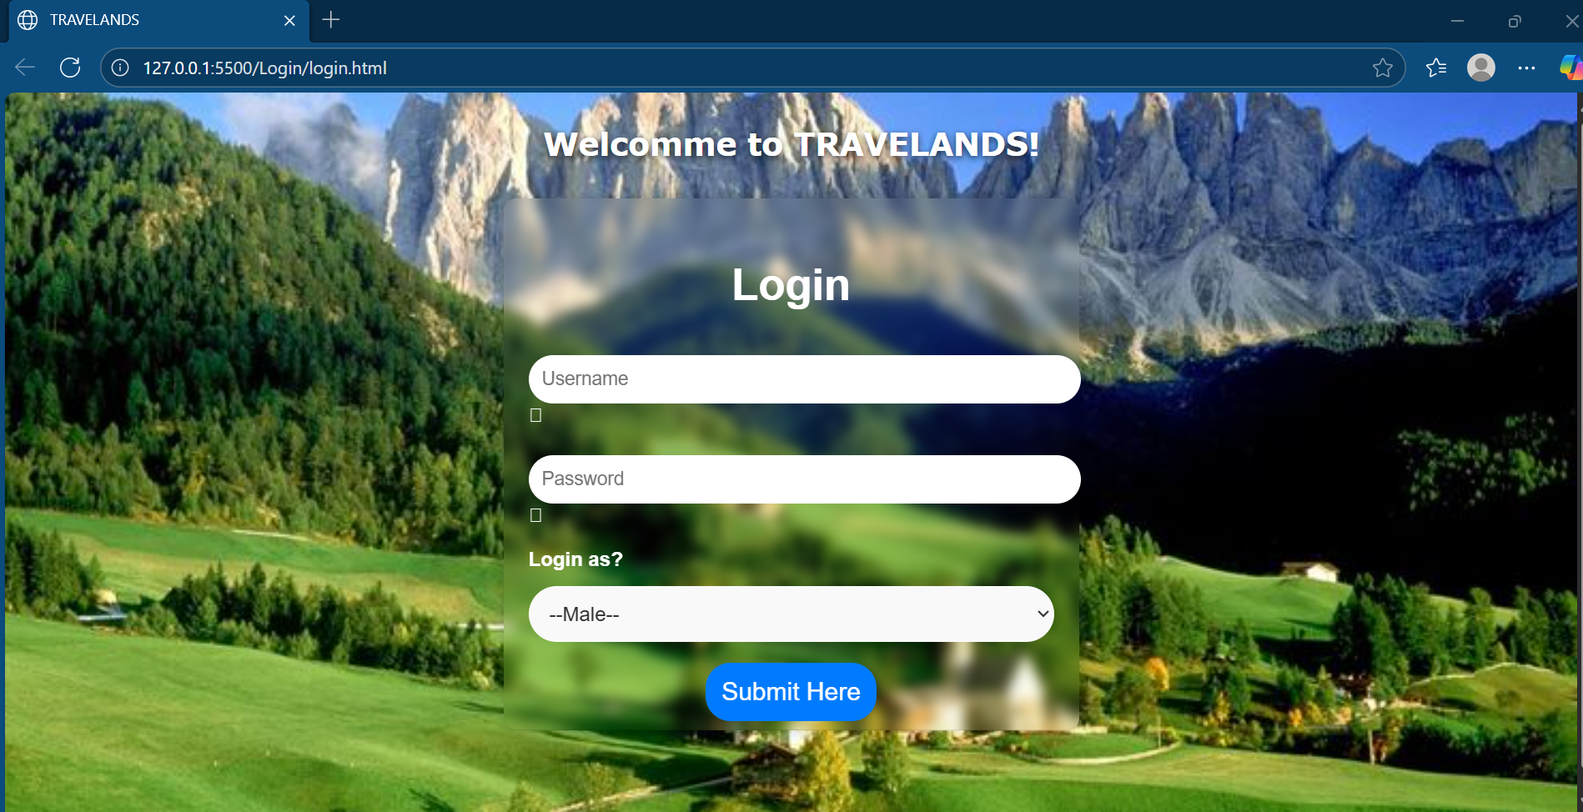

# 3. Frameset

After the user clicks the submit button on the login page, the Main Page (index.html or main.html) functions as the central structure of the website. This page uses a frameset layout that divides the screen into two sections: a navigation bar and a main content area. This layout allows the content in one frame to change dynamically while keeping the navigation visible.

On the right or main section, there is a search column for destinations, but if you scroll down, there will be a section for destinations based on their countries. Below the destination section, there are testimonial reviews, for more details, see the next point.

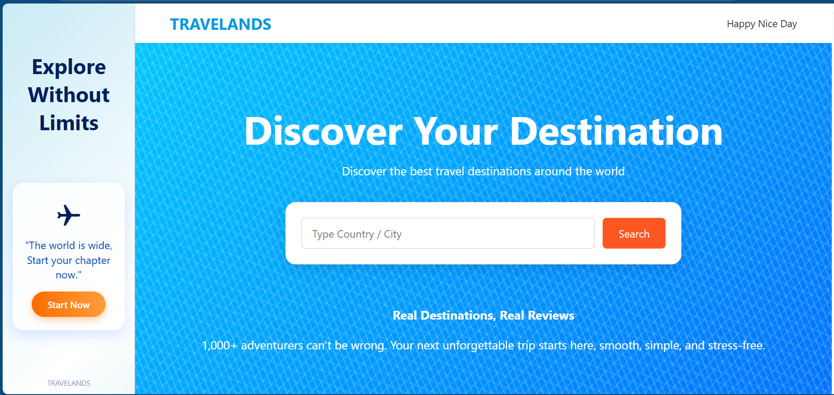

# 4. Navigation Page

To the left of the main [content] there is page navigation. The Navigation Page (nav.html) contains links to the main sections within the website. It allows users to move between countries or information pages back to the main page. The navigation layout is designed using styles in HTML to arrange the links neatly and maintain consistency throughout the frameset. It also serves as a page to enhance aesthetics.



# 5. Destination Section

The destination pages are organized into separate folders under the Main directory. Each destination has its own set of HTML files, CSS files and images. For example, Canada includes pages such as canada_main.html, canada_info.html, and supporting images like Banff.jpg and Niagara.jpg. These pages display information about travel destinations with accompanying images and descriptions.

Similarly, Indonesia’s section (indonesia_info.html) presents tourist destinations such as Borobudur and Bromo. Each page uses consistent layout and color schemes for design uniformity.

In this section, there are several destination options based on the country. When the cursor hovers over the flag box, a popping effect will appear.

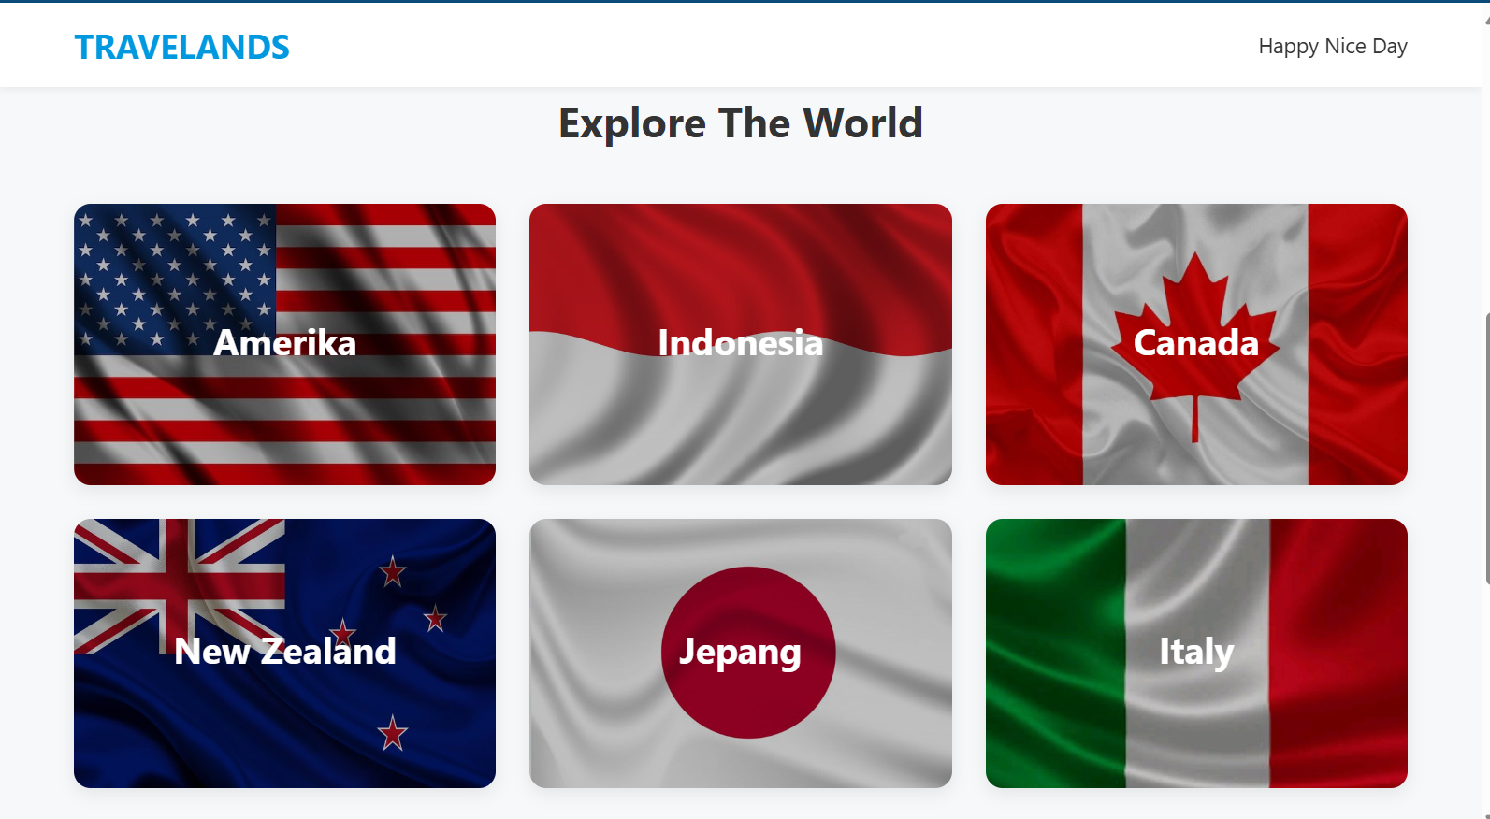

After the user selects the destination country, they will be directed to the destination page, which is divided into two framesets. The left side is used as a destination filter that can be checked or selected, and the right side displays the available destinations.

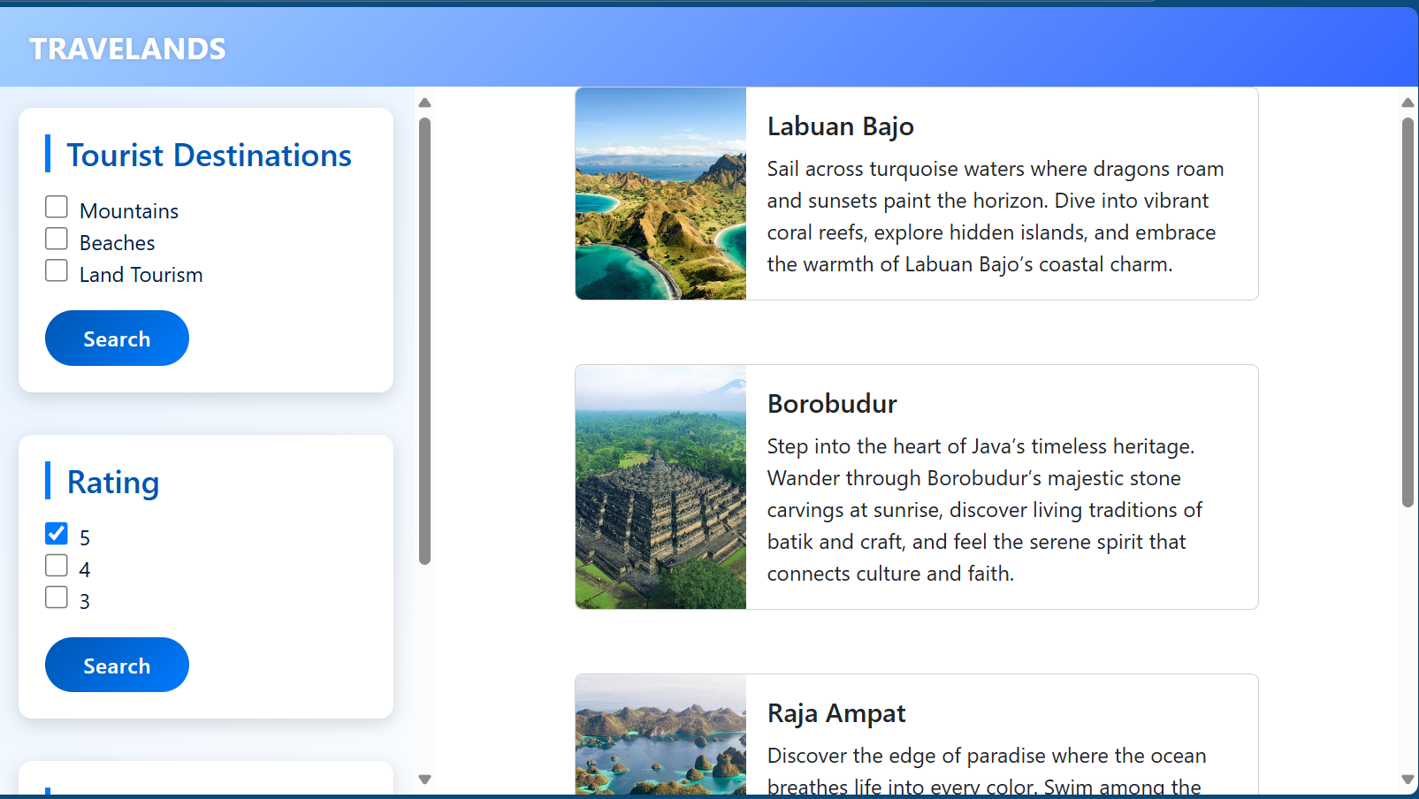

# 6. Testimon ial Section

In this section, there are testimonials from several travelers who have traveled together. The goal is to increase trust strengthen users' trust in TRAVELANDS

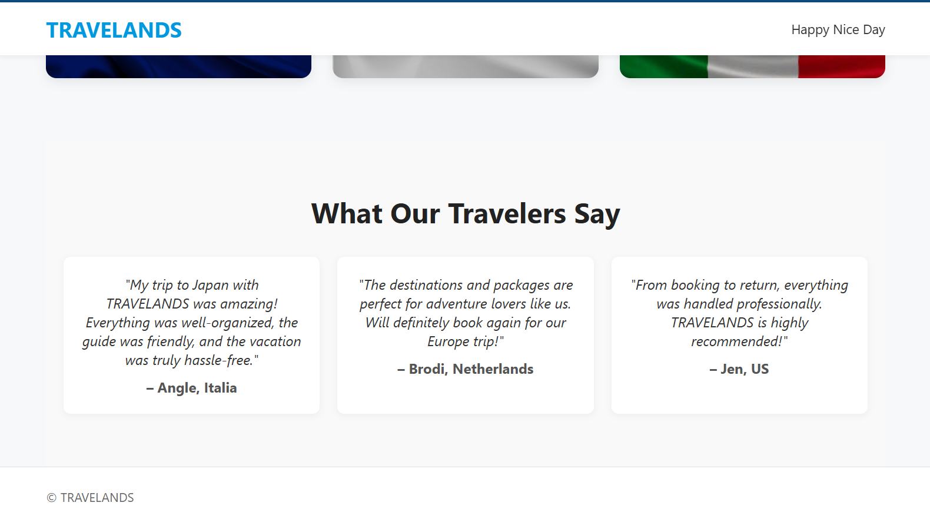

# 7. CSS Styling and Design

The project applies multiple CSS files (login.css, main.css, nav.css, info.css) to define layout, color, and text properties. Each page maintains a coherent visual identity through consistent use of colors, font sizes, and spacing. CSS also enhances user interaction through hover effects and alignment styling. Background images are used to create visual appeal, while text remains clear and legible.

# 8. Conclusion

This project demonstrates the implementation of basic web design principles using HTML and CSS. It integrates navigation, frameset-based layout, and destination pages to create a complete multi-page website. Through organized structure and consistent design.